Task -30 Practice Question By using Function
Question 1 — Banking ATM PIN Verification
def pin_login():
correct_pin="1234"
for i in range (4):
pin=input("Enter must 4-Digits pin:")
if len(pin) <= 4 and i <= 3:
if pin == correct_pin and len(pin)==4:
print("Login successfully")
break
else:
print("incorrect pin")
else:
print("temprory blocked")
login = pin_login()
print(login)
Expected Output
- Successful login
- OR account temporarily blocked
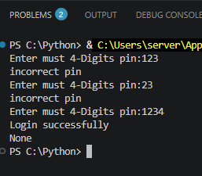

Question 2 — Hospital Temperature Monitoring
def temp_read():
sum=0
for i in range (1,10):
temp =int(input("Enter the temperature : "))
if temp > 1:
sum += temp
avg= sum/i
else:
print("Negative Reading")
break
print("Total Reading :")
print(sum)
print("Average of Temperature Reading :")
print(avg)
temp_read()
Expected Output
- Total readings recorded
- Average temperature
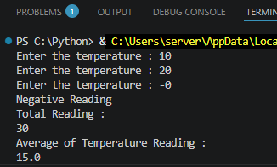
Question 3 — Online Shopping Cart
def product_price():
product_price=0
total_amount=0
count=0
for i in range(10):
product_price = float(input("Add Products Price:"))
if product_price >= 1:
count=count+1
total_amount = total_amount + product_price
else:
print("Negative Price")
break
print("Number Of Products:")
print(count)
print("Total Amount of Product")
print(total_amount)
product_price()
Expected Output
- Total bill
- Number of Products
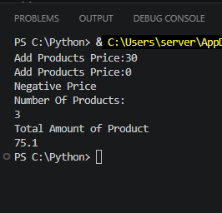
Question 4 — School Attendance
def std_attendace():
std=0
count=0
print("************Attendance Of Students****************")
for i in range(1,11):
print(i,"\t", i+10,"\t",i+20,"\t",i+30)
count= count + 4
print("Attendance of all Students :")
print(count)
std_attendace()
Expected Output
Attendance roll numbers
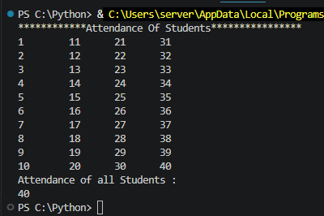

Question 5 — Retail Discount Days

def discount():
for i in range(1,8):
print(i,"Day","\t","Discount Available Today")
discount()
Expected Output
Seven announcements
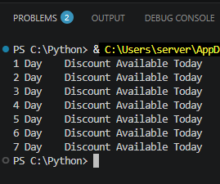

Question 6 — HR Employee ID Validation

def emp_id():
Corect_id=1234
emp_id=1
while emp_id:
emp_id = int(input("Enter Your Id :"))
if emp_id == Corect_id:
print("Valid Id")
break
print("Invalid ID")
emp_id()
Expected Output
Valid Employee ID accepted.
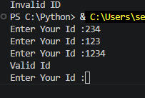
Question 7 — Telecom Recharge
def recharge():
recharge_amt = -1
Total_recharge= 0
while recharge_amt != 0 :
recharge_amt = int(input("Enter Recharge amount :"))
if recharge_amt <= 0:
print("Stop the amount")
break

else:
Total_recharge = Total_recharge + recharge_amt
print("Total recharge amount ==",Total_recharge)
recharge()
Expected Output
Total recharge value
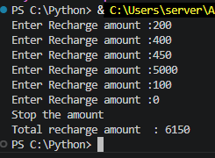
Question 8 — Travel Ticket Booking
def tickect_booking():
tickets_book=0
for i in range(1,16):
print("Seat :",i,"\t","Seat :",i+15)

tickect_booking()
Expected Output
Seat allocation numbers.
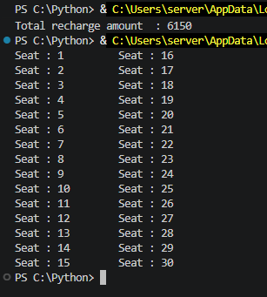

Question 9 — Cybersecurity Login Attempts
def check_pass():
Correct_password= 230
attempt=0
while attempt<5:
password = int(input("Enter the Correct Password :"))
if Correct_password==password:
print("Access Granted")
break
else:
attempt = attempt + 1
print("Wrong password")

if attempt==5:
print("Account Locked")

check_pass()
Expected Output
Access Granted or Account Locked
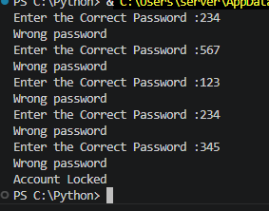

Question 10 — Manufacturing Production Counter
def product():
total_production = 0
production = -1
while production != 0:
production = int(input("Enter Production Count (0 to Stop): "))
if production <= 0:
print("Shift Ended")
break
else:
total_production = total_production + production

print("Total Products Manufactured :", total_production)
product()
Expected Output
Total products manufactured.
